1. Install Jdk21
2. Download eclipse zip and extract the contents to C:\
3. Create a Maven Project from eclipse as:
4. 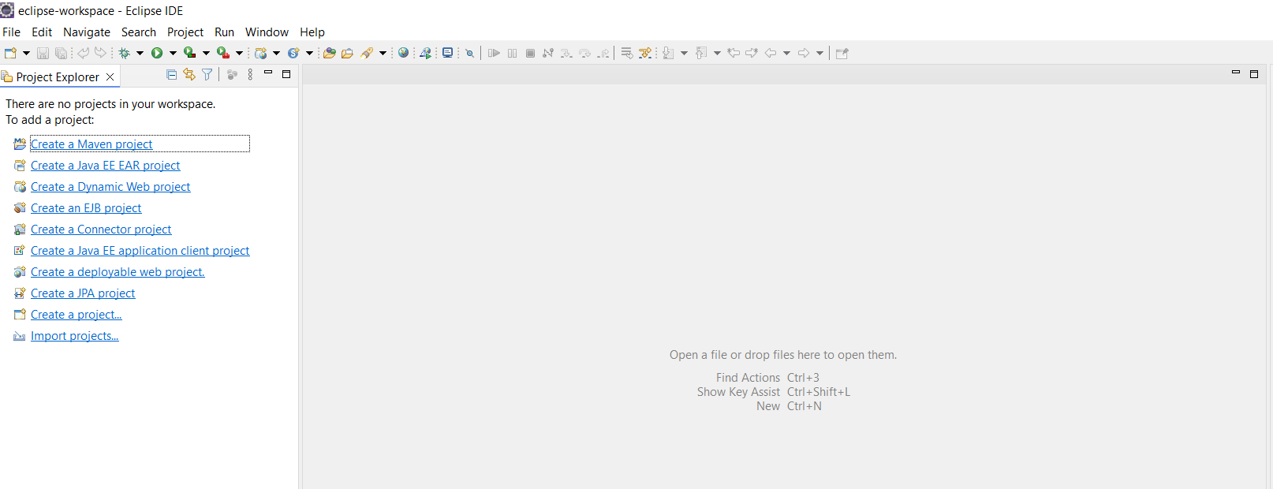
5. 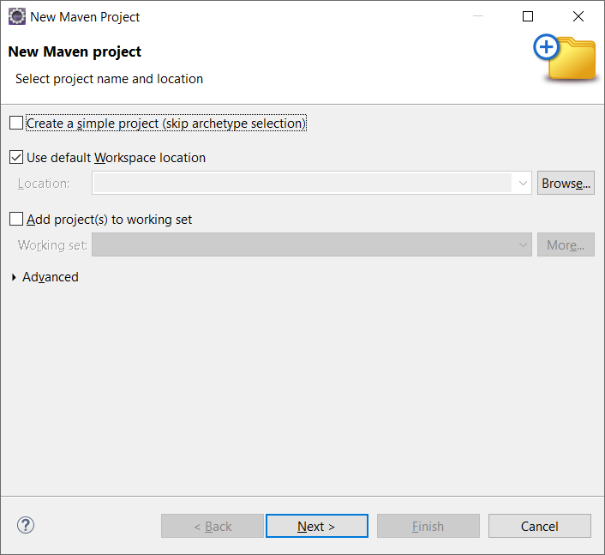
6. Click Next
7. 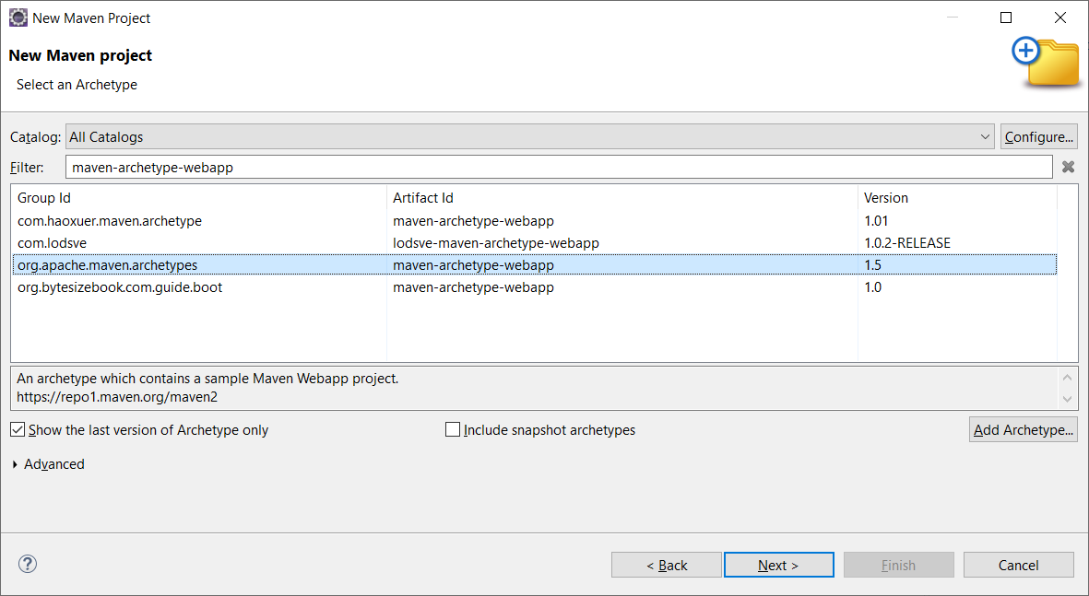
8. 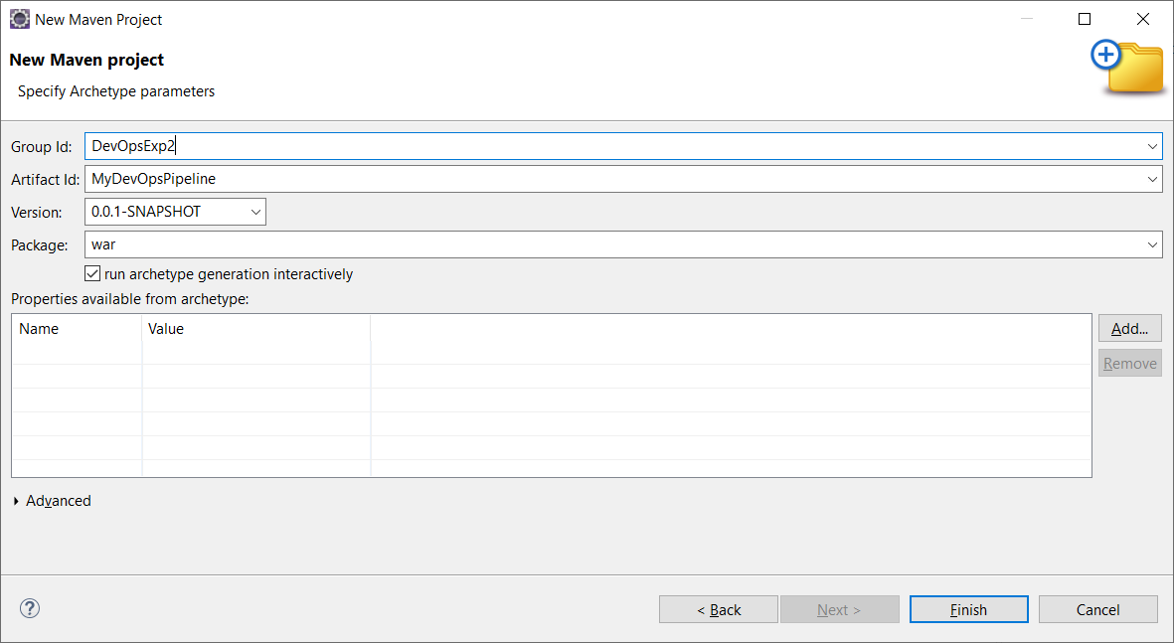
9. Click Finish
10. 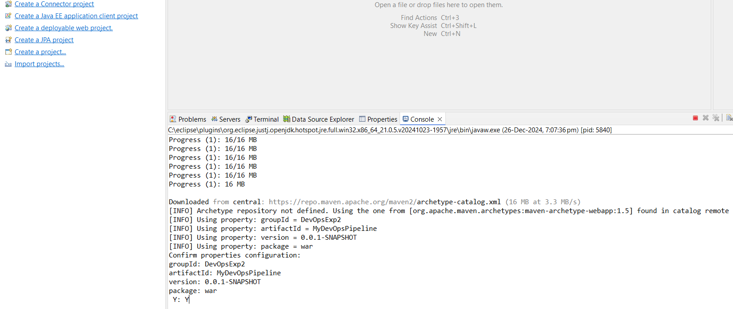
11. Type Y and Press enter, You should see a Build Success message as below:
12. 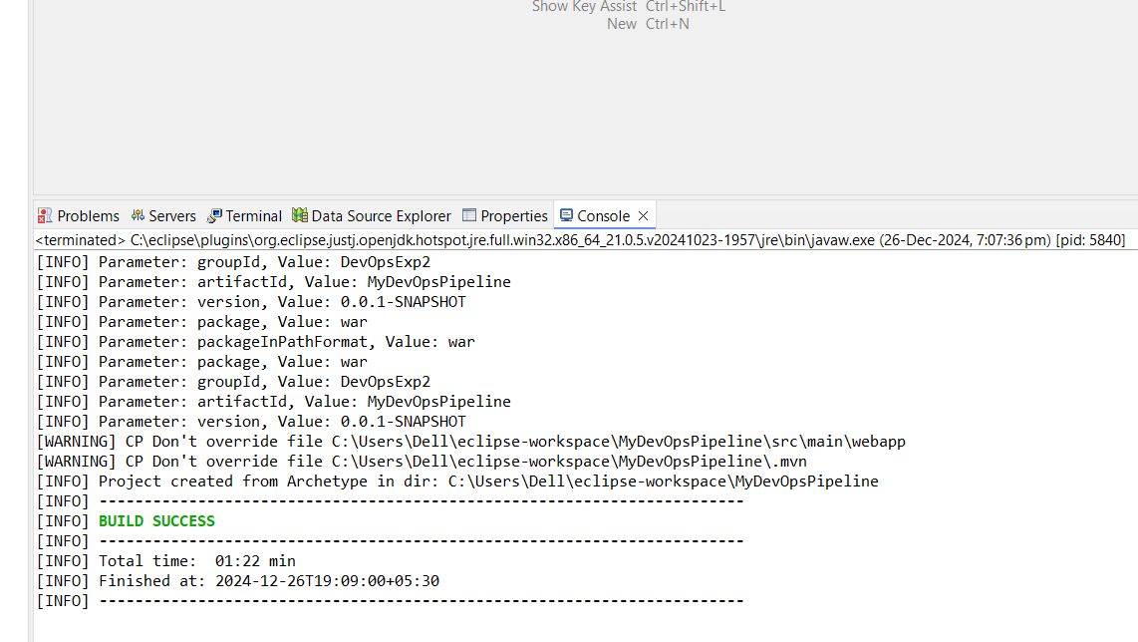
13. You should see the below structure in eclipse:

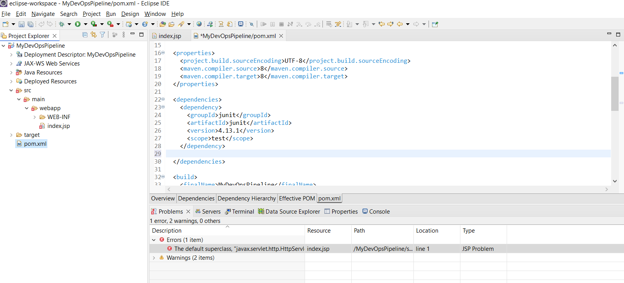

Click on pom.xml to open the file.

Add the below dependencies to the pom.xml:

<dependency>

<groupId>javax.servlet</groupId>

<artifactId>javax.servlet-api</artifactId>

<version>3.1.0</version>

<scope>provided</scope>

</dependency>

<dependency>

<groupId>org.testng</groupId>

<artifactId>testng</artifactId>

<version>7.10.2</version>

<scope>test</scope>

</dependency>

<dependency>

<groupId>org.seleniumhq.selenium</groupId>

<artifactId>selenium-java</artifactId>

<version>4.27.0</version>

</dependency>

1. Install Tomcat 9.0-
2. Download apache-tomcat-9.0.98.zip
3. Extract to C:\
4. Add Tomcat to Runtime by:
5. Open Project Properties, and Click on Targetted Runtime

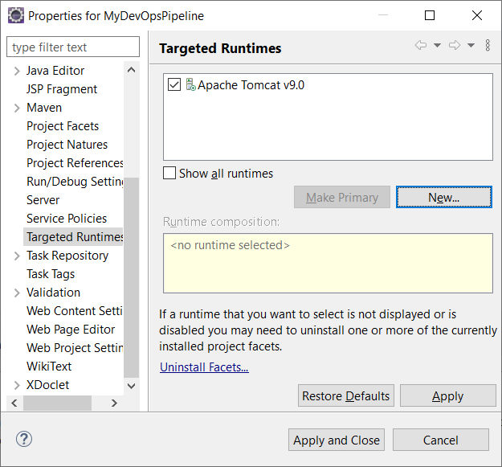

Click on New and Select Apache Tomcatv9.0 as below, and click Next

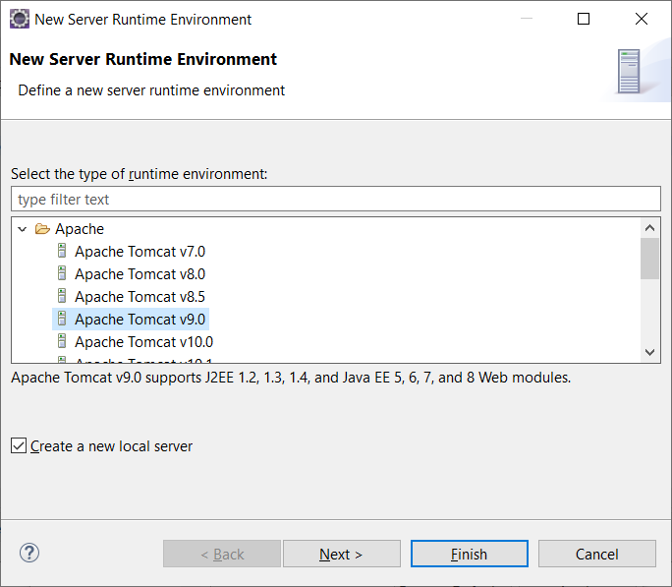

Give the extracted folder of Tomcat 9.0 as below, and Click Finish.

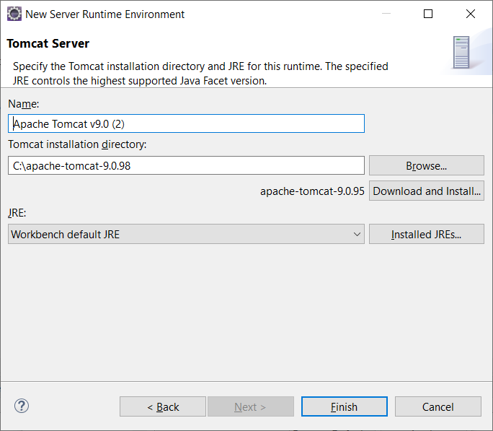,

1. Open index.jsp and Press Ctrl+Shift+f , this will set the alignment of the jsp.
2. Click Help-> Install New Software, and give https://testng.org/testng-eclipse-update-site/ and Click Add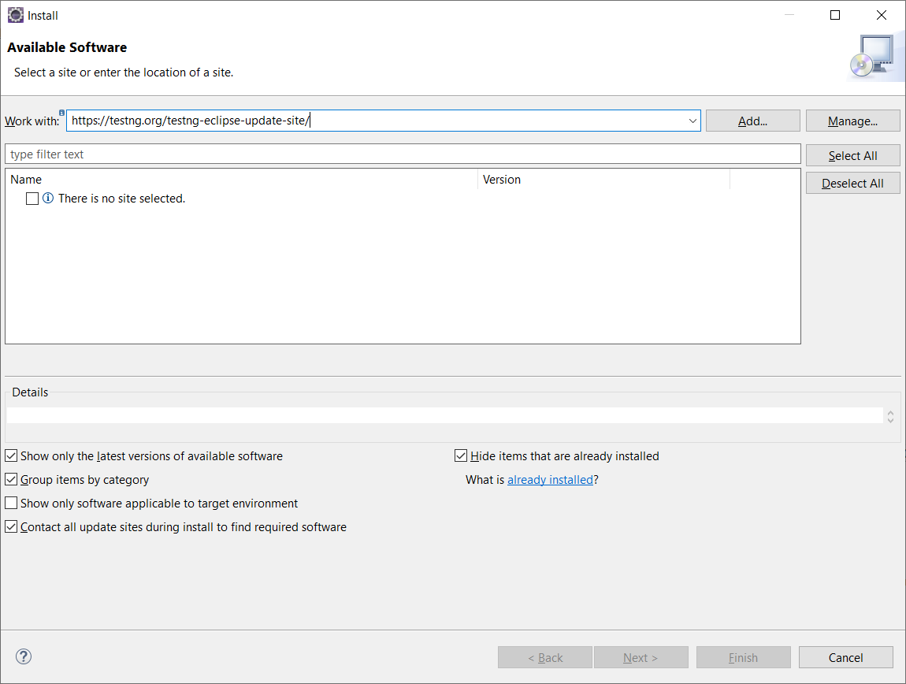

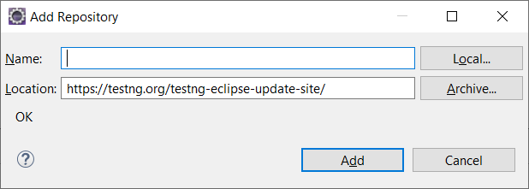

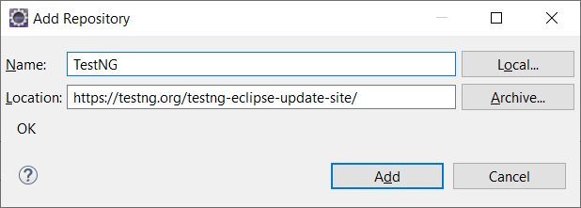

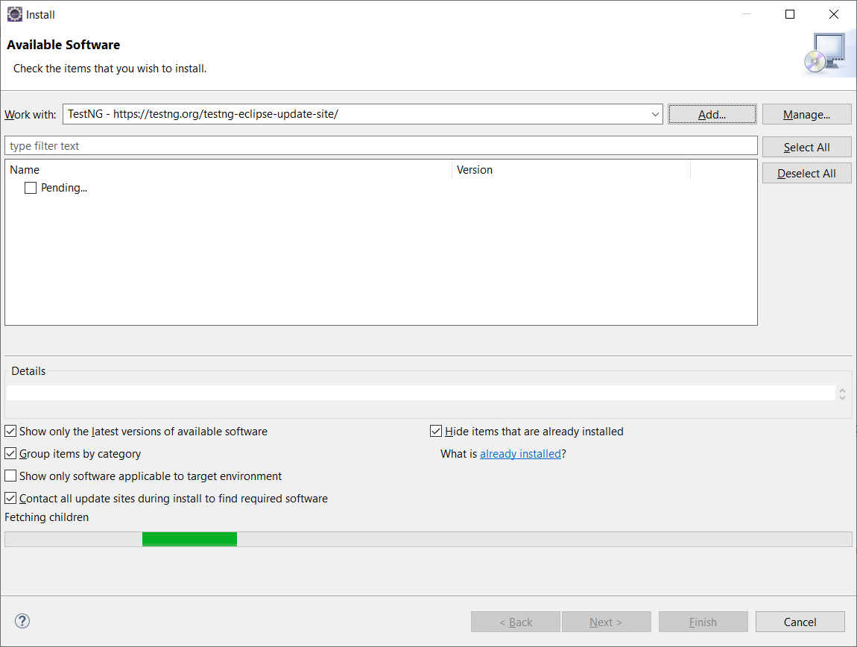

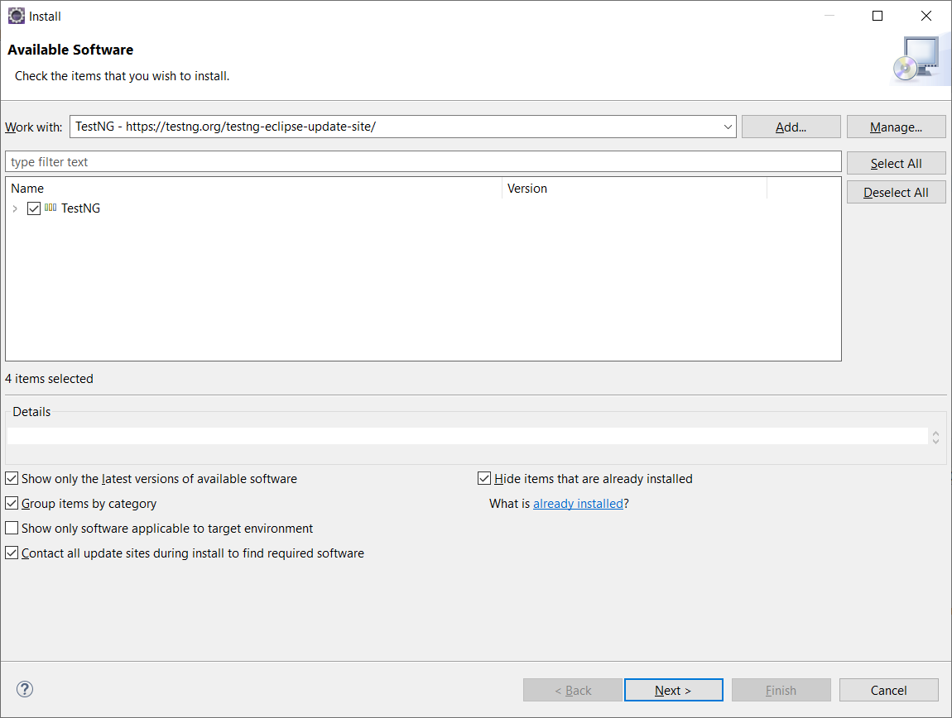

Click Next,

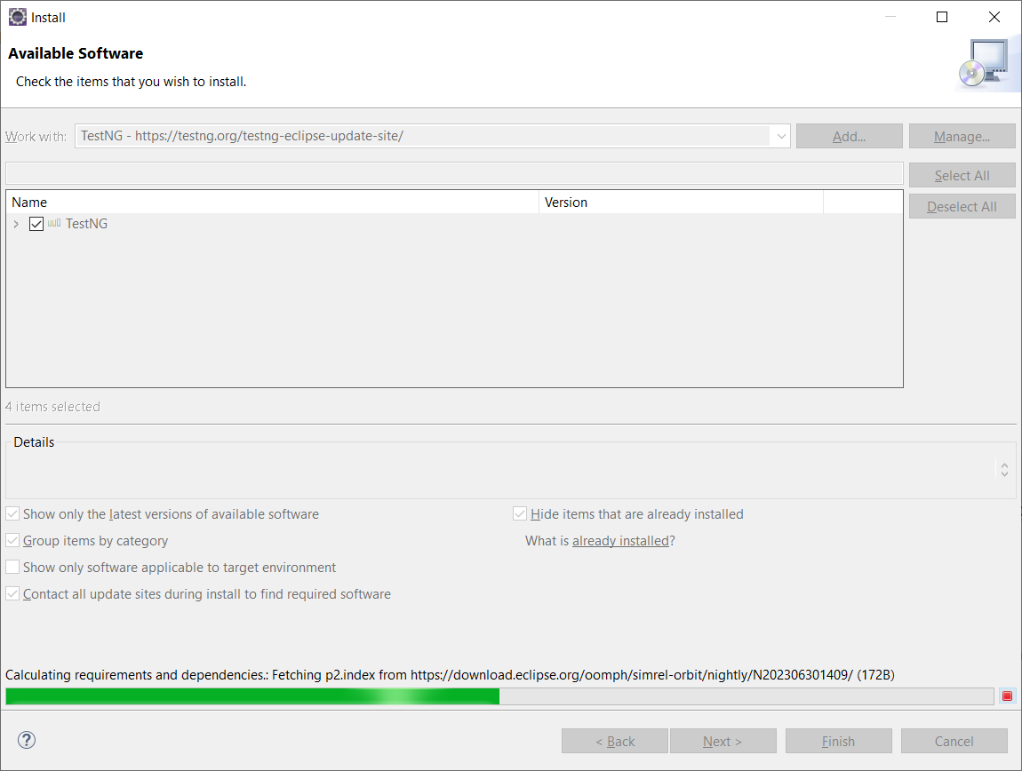

Wait until you get the below;

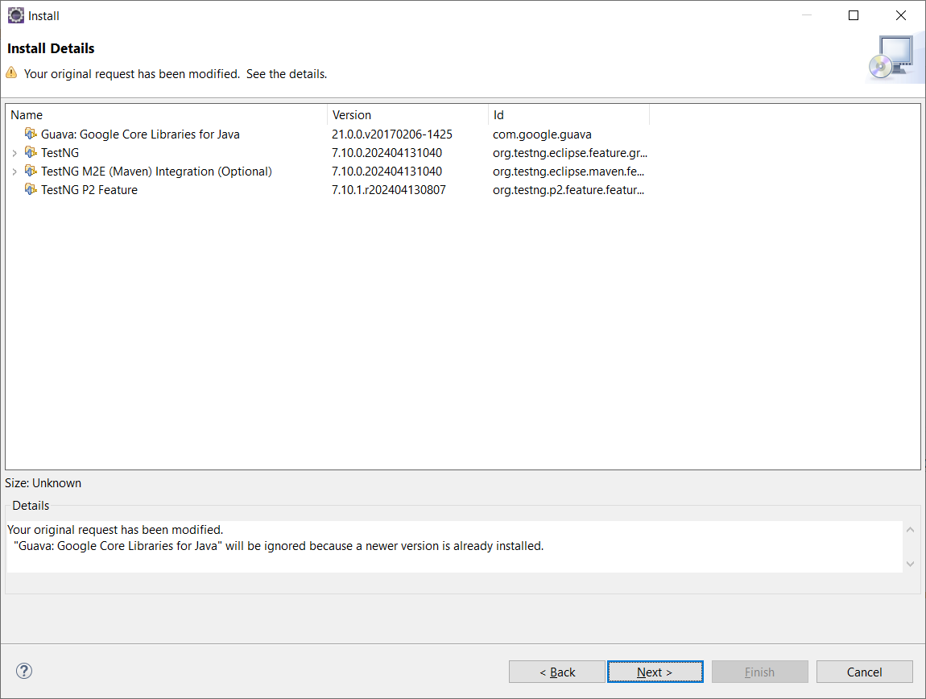

Click Next, and accept the license through the radio button and then click Finish as below:

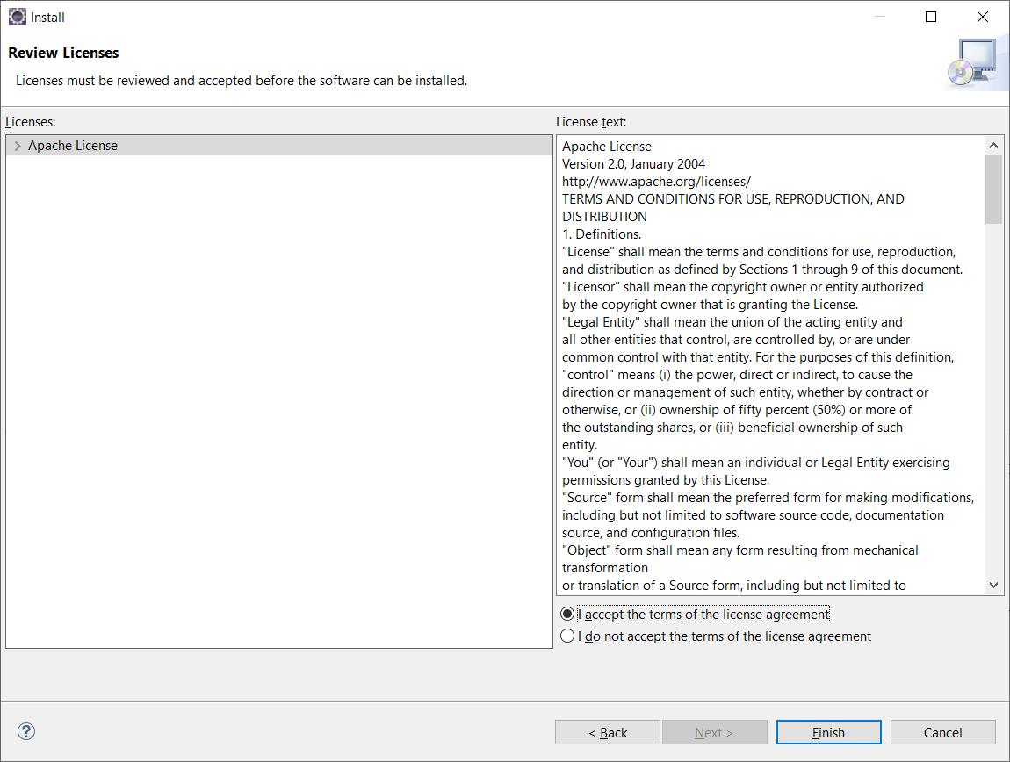

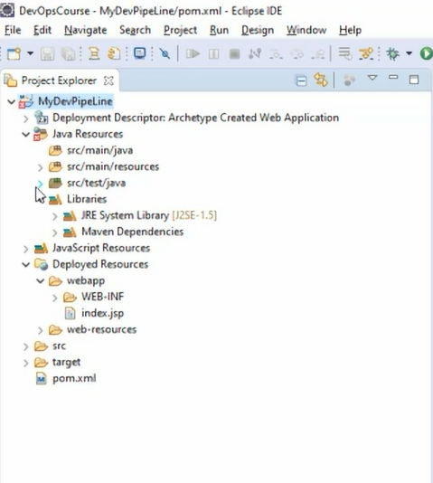

Source code in src/main/java and test cases in src/test/java

Goto Eclipse Marketplace and install EGIT

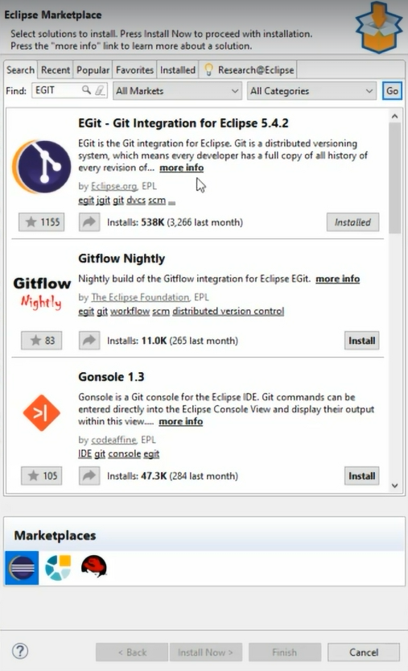

Project-> Team🡪 share Project

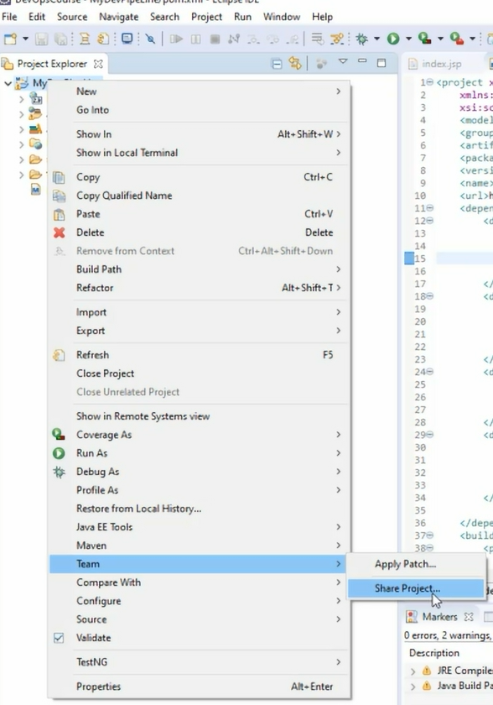

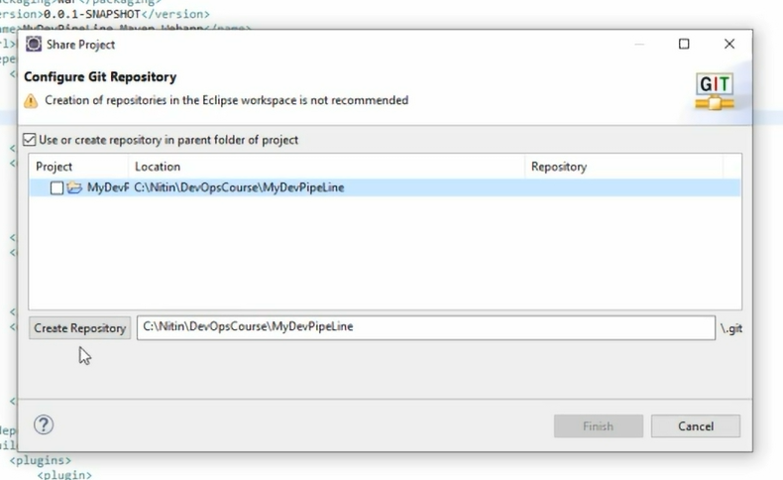

Click Create Repository,

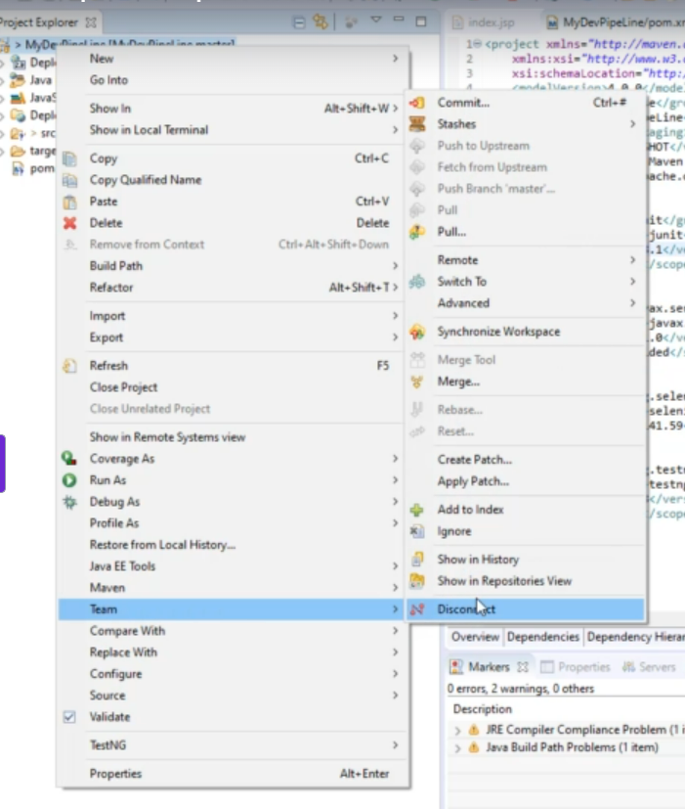

Goto Github and create a repository

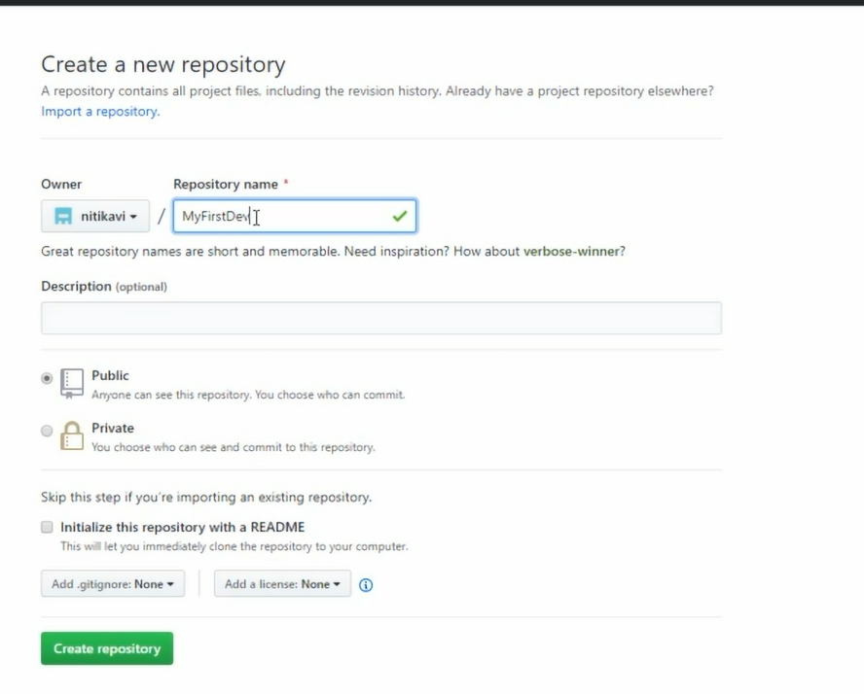

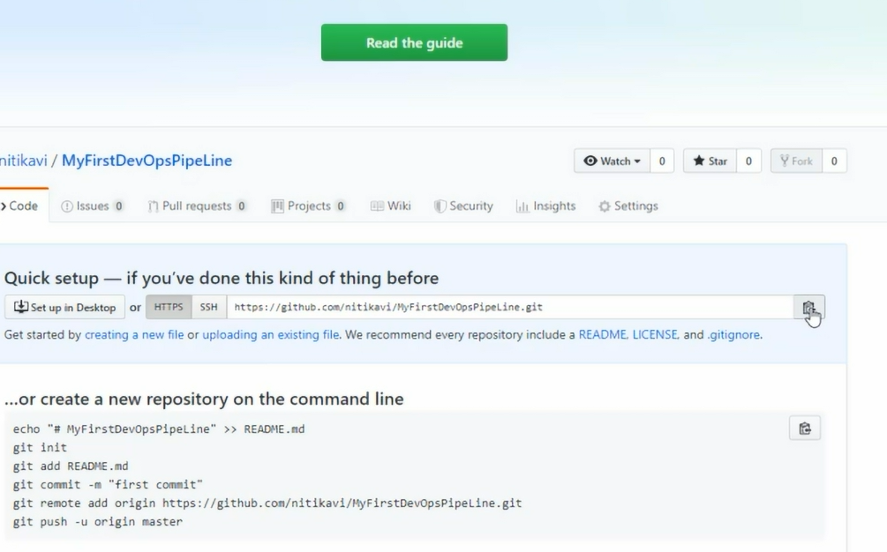

Now, go back to Eclipse and commit,

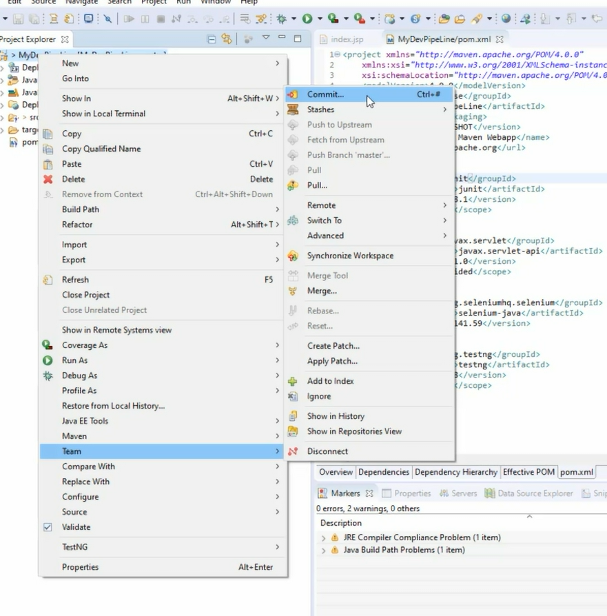

It shows the project is unstaged:

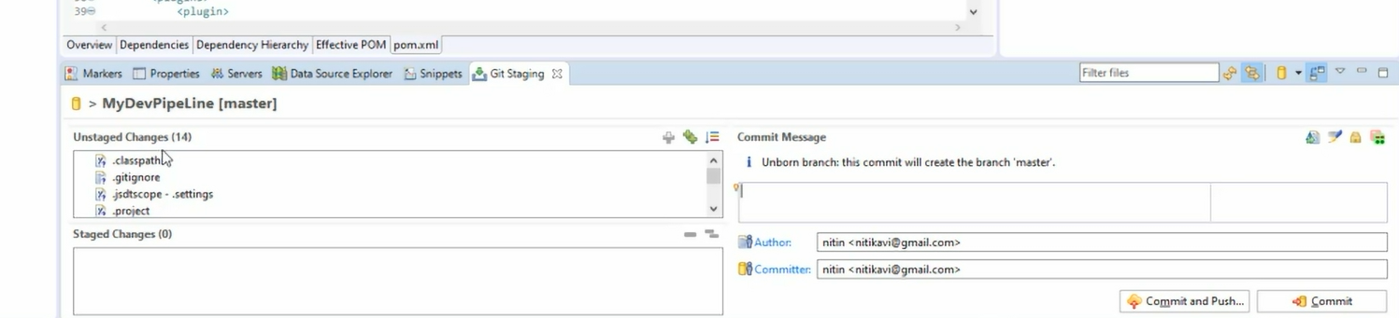

Click on green icon to add files to staging

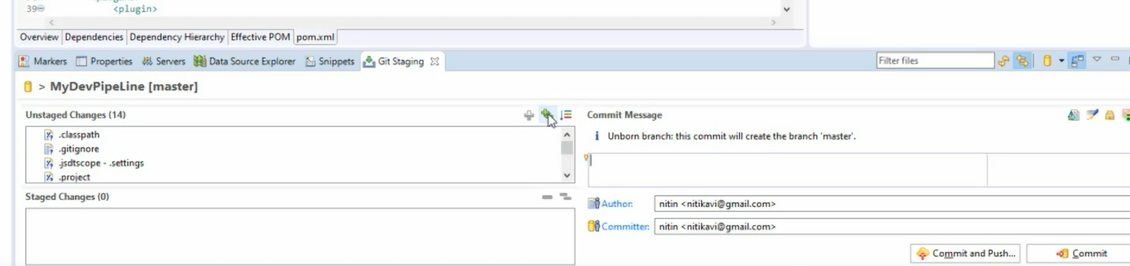

It looks as below

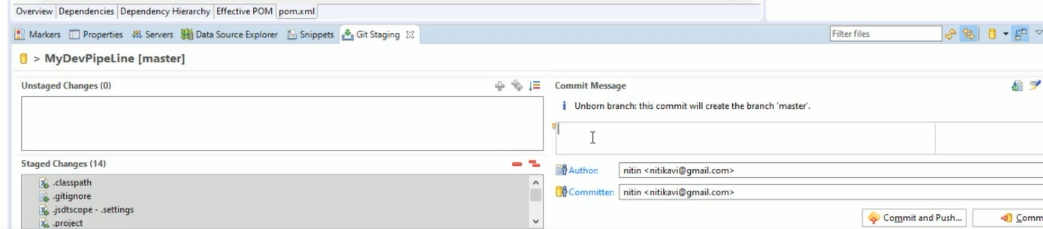

Write a commit message and select Commit and Push.

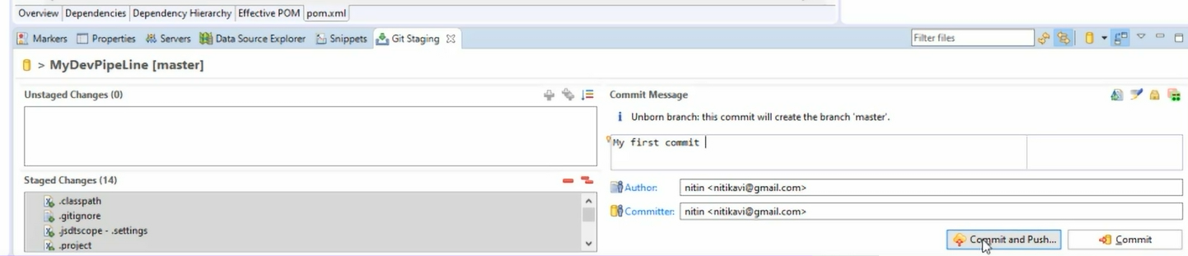

It will ask for repository, automatically pop up otherwise give the URL, username and password for github

Click Next

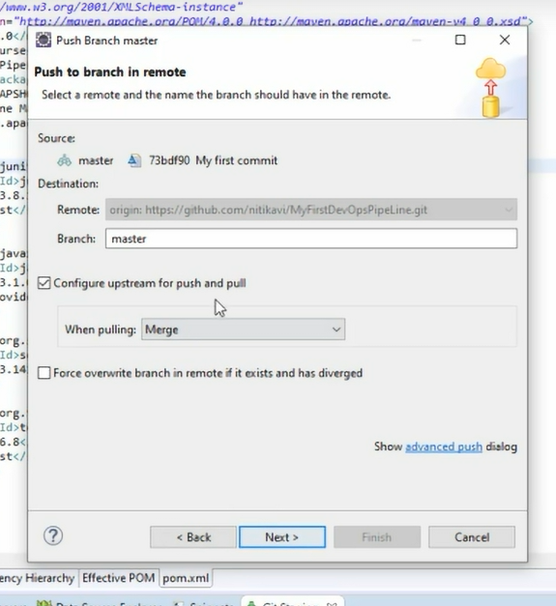

Click Next

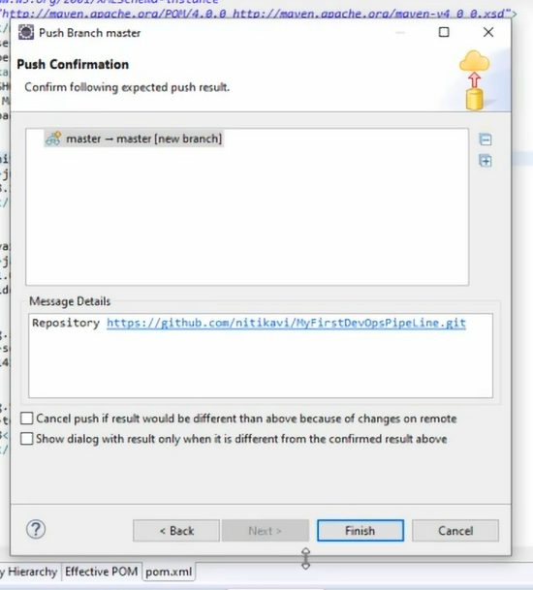

Click Finish

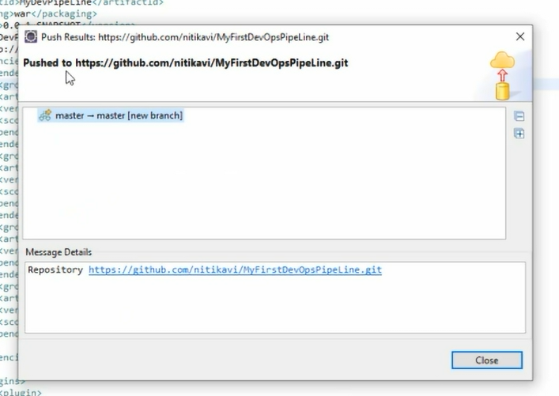

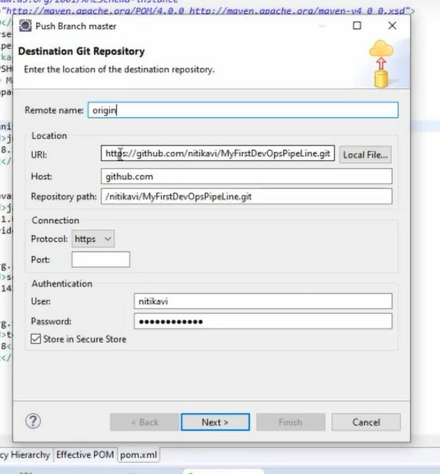

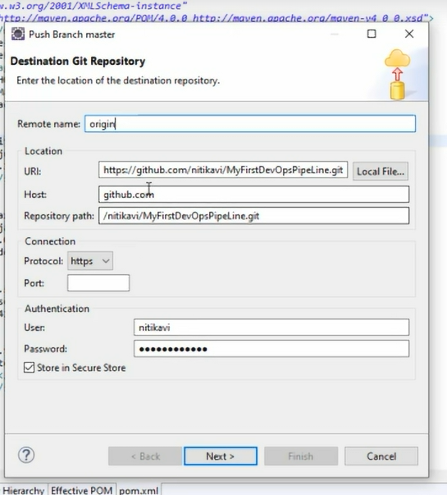

Goto Github and check the repository:

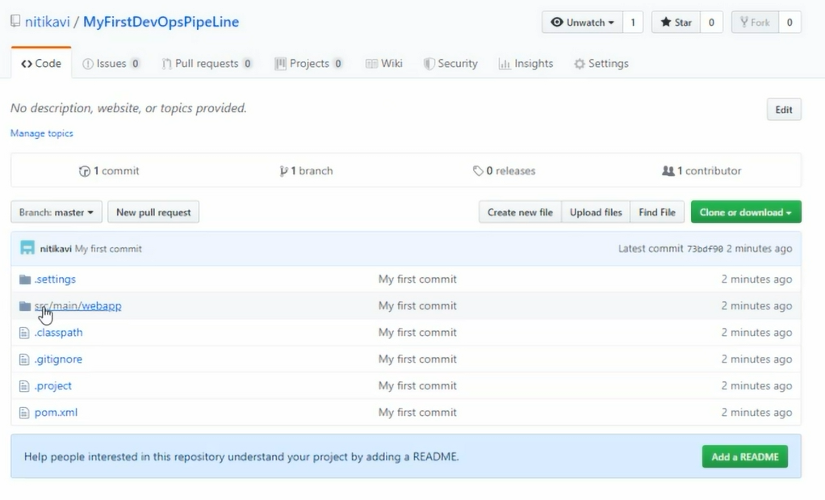

Src/test is not checked in as there are no files, so you can create some testing class as below:

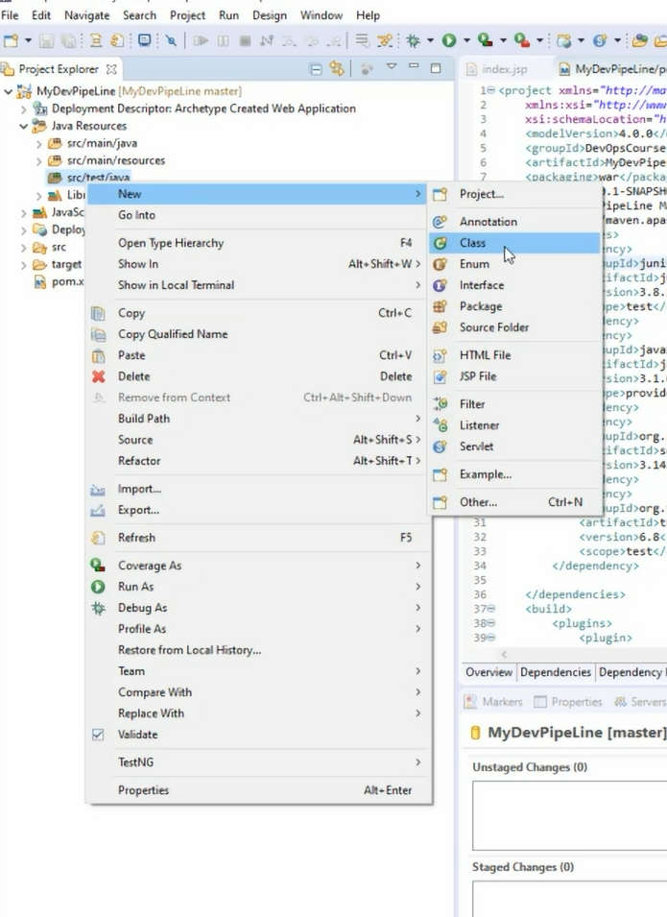

Give a Name and check the checkbox to create public static void main and click Finish.

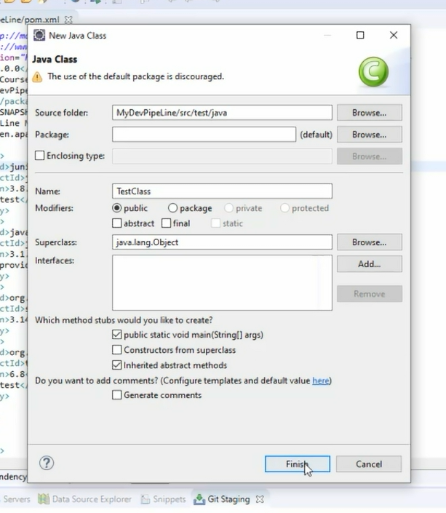

Add a package name **com.internal.Tests;**

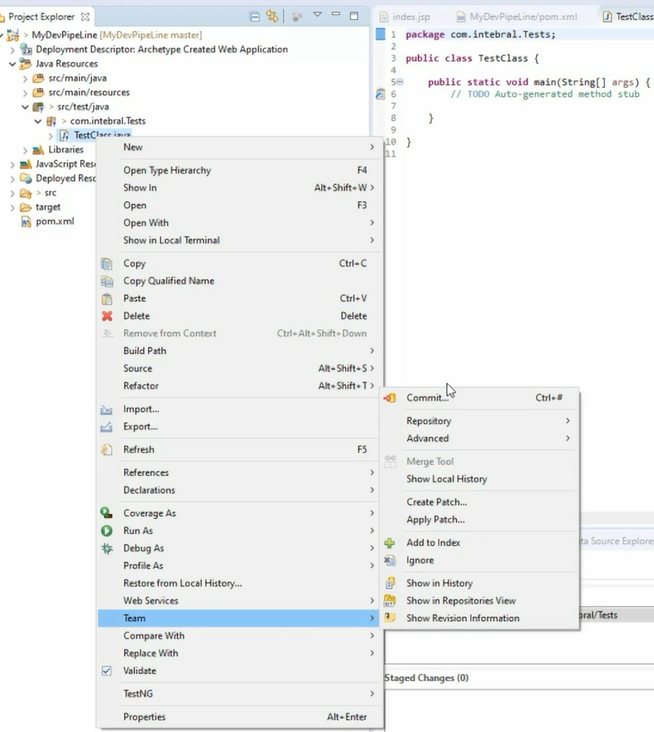

Add to staging, then give commit message and commit

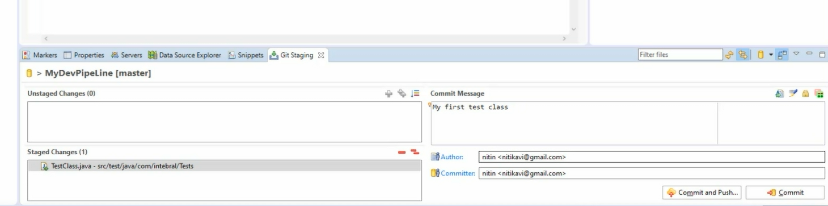

Note For setting surefire for selenium and Java 1.8 compiler for

Add the below to pom.xml under plugins:

